**Enable IIS on local machine**

This is the point-and-click method to set up a website in IIS. It’s the ideal method if you haven’t learned PowerShell or Windows commands.

1. Start typing “turn on windows” in the Search bar. The **Turn Windows features on or off** utility will show as a result. Click on it.

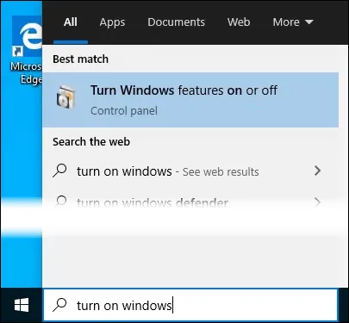

1. The **Windows Features** window will open. It may take a bit for the different features to load. Once it does, click on the checkbox next to **Internet Information Services** and then click the **OK** button.

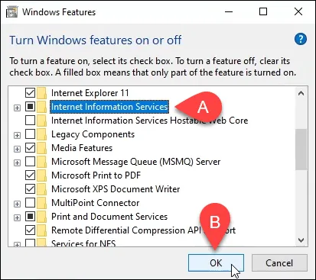

1. The installation will begin and can take several minutes. Once it’s completed, click on the **Close** button.

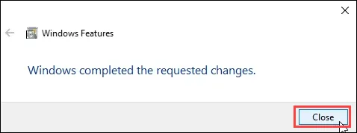

1. To ensure that IIS is installed and working, type **IIS** in the **Search** bar near the **Start** button. You’ll see the **Internet Information Services Manager** as a result. Click on that to open it.

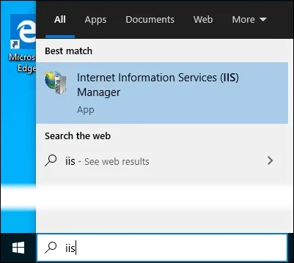

1. When IIS Manager opens, look in the left pane of the window under **Connections**. Expand the tree menu until you see **Default Web Site.** That’s a placeholder site that is installed with IIS. Click on it to select it.

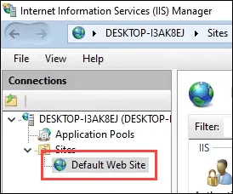

1. On the right side of the IIS Manager look under the **Browse Website** section. Click on **Browse *:80 (http).** That will open the default web site in your default web browser.

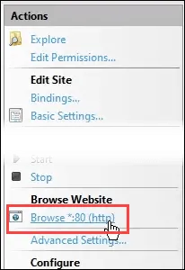

1. You’ll see a web page like the following. Notice in the address bar that it says **localhost**. That’s the address to type in to go to your new website.

